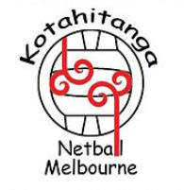
KOTAHITANGA NETBALL MELBOURNE
2021 ANNUAL CLUB TOURNAMENT
SUNDAY 3RD OCTOBER 2021
Gloria Pyke Netball Centre, Bennett Road, Dandenong
Club/Team Name:
Contact Name: Contact No:
Email Address:
Fee and Prize structure (fee includes umpire)
Juniors entry fee $150 (9/U to 19/Us)
Senior Ladies Open & Mixed $250 entry with $500 cash prize for Grand Final Winner
Seniors Reserve $200 entry fee with $400 cash prize for Grand Final Winner.
SECTION ENTERING: | OPEN | RESERVE | TOTAL TEAMS | TOTAL ENTRY COST
9 and under Mixed |  |  |  | ______ x $150 =
11 and under Mixed |  |  |  | ______ x $150 =
13 and under Mixed |  |  |  | ______ x $150 =
15 and under Mixed |  |  |  | ______ x $150 =
19 and under Mixed |  | N/A |  | ______ x $150 =
Senior Ladies |  |  |  | ______ x $250 (open) =  ______ x $200 (Res) =
Senior Mixed |  |  |  | ______ x $250 =
TOTAL TEAMS ENTERED |  |  |  | = $
Please send entry forms and or enquiries to: committee@kotahitanganetballmelbourne.com
Phone enquiries: Ngaire 0401 472 484 or Candice 0400 880 593
TERMS AND CONDITIONS
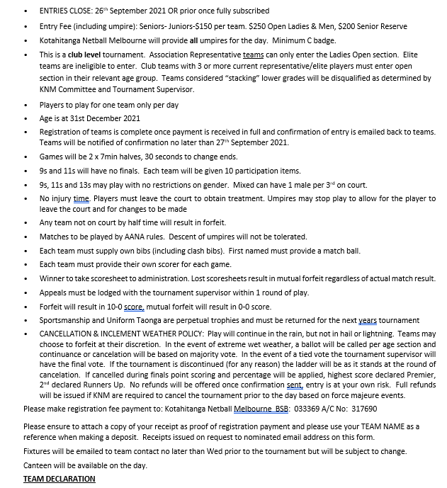
(KOTAHITANGA NETBALL TOURNAMENT 2021)

I __________________hereby understand and accept all tournament rules and any terms and conditions as outlined in this registration form for our team/s __________________ _______________________________
Signed: Date:

